2022-2023

VICSRC EXECUTIVE COMMITTEE ELECTION INFORMATION PACK

In this pack you will find...

A glossary of key terms An election timeline
An overview of the nomination process Information about VicSRC
Information about the Student Executive Advisory Committee
Election guidelines
A position description for Executive Committee members
Frequently asked questions

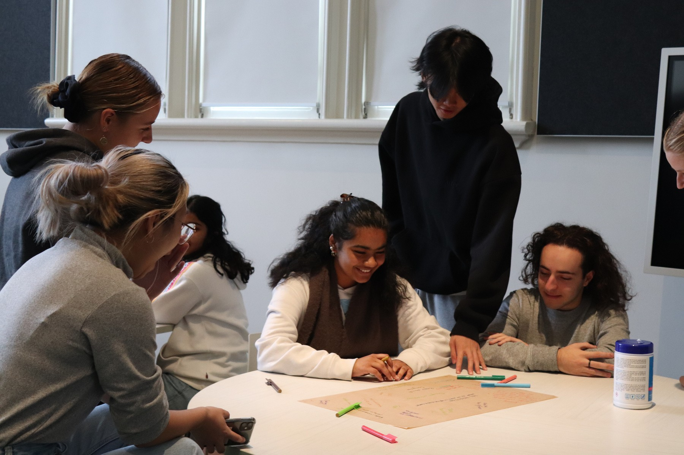
Illustrations in this pack are courtesy of Sarah the Firth

Hello!

Hello!

Linh and Thanh here. We are the VicSRC returning officers for 2022.

Our job is to make sure the election is fair and is conducted in line with VicSRC’s policies and processes. We are also responsible for overseeing all nominations, making sure the ballot paper and voter roll is accurate, and verifying and announcing the results of the election. As ROs, we must be impartial throughout this process. We do all this with the help of our wonderful staff.

Just like last year, this year's election will be held online so that a greater proportion of students can access the process and we're more representative. We commend your interest in wanting to be a part of the Executive Committee and wish you the best of luck with your nomination!

If you have any questions, please don’t hesitate to contact us at election@vicsrc.org.au.

Cheers!
Linh and Thanh

Linh Thanh

Glossary

Here are a few terms you will come across a lot in this document to help you understand what we’re talking about.

Word or phrase | What it means
VicSRC | Victorian Student Representative Council
Executive Committee | VicSRC Student Executive Advisory Committee
Nominees and candidates | People nominating and running for election to the VicSRC Executive Committee.
Voters | People who are eligible to vote in the VicSRC Executive Election, namely VicSRC Student Community members who are school-aged students in Victoria.
Returning officers | Two current VicRC Executive Committee members who are responsible for running the election and announcing the results
Governance | How a group or organisation is run. This includes the structures and systems of how decisions are made in a group or organisation. At VicSRC decisions are often made collaboratively between the Executive Committee, the adult Board of Trustees, and the staff team.

Election timeline

Nominations open 9am
MON
27
JUNE
MON 18
- SUN 31 JULY
MON
25
JULY

MON
1
AUG

SUN
14
AUG
WED
24
AUG

Nominations close 11.59pm
SUN
17
JULY

Campaigning period. Get other students to sign up to the Student Community and vote for you!

Deadline to sign up to the Student Community to be able to vote 12pm

Voting opens 9am! Instructions will be sent via email.

Voting closes 11.59pm

All candidates will know the outcome.

Nomination process

Sign up to the VicSRC Student Community

Sign up
Talk with a supportive staff member at your school about this opportunity.

Talk

01.
02.
03.
04.
05.

Read
Read through this VicSRC Executive Committee
election info pack

Chat
Chat to a parent or guardian so they know what you are nominating for

Book
Book yourself into an information session

Get your parent or guardian to sign the permission form and talent release form

Permission

Encourage your friends to sign up to the Student Community
to vote!!!

Encourage

06.
07.
08.
09.
10

Nomination

Fill
Vote

Get your nomination statement and quote ready
Fill out the nomination form Submit your vote and wait for the results

What is VicSRC?
Victorian Student Representative Council (VicSRC) was created by students to be a voice for students at the highest levels of decision-making in Victorian education.

VicSRC is led by a team of 15 secondary school aged students (the Student Executive Advisory Committee) that make decisions collaboratively with a group of six adults (Board of Trustees) about how VicSRC operates, what programs it offers and how it hears from students about what changes need to be made in education.

A team of staff members put these decisions into action with consistent advice from the Student Executive Advisory Committee.

Education that's flexible, relevant and includes all students in all decisions.
VISION
We stand with and for students to elevate their voices to be heard.
MISSION

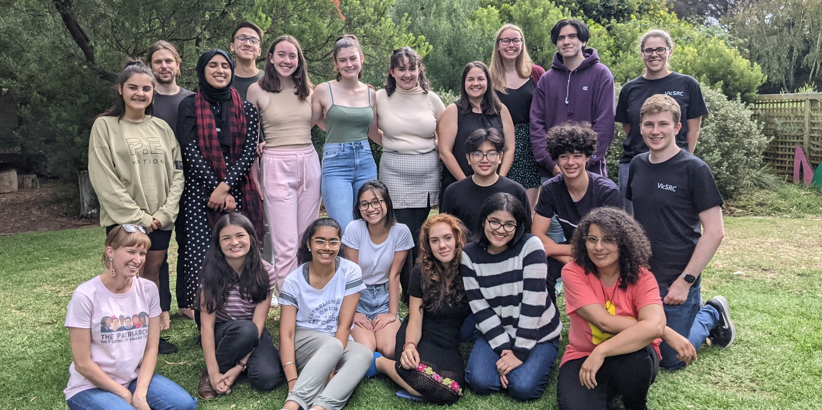
You can find out more about VicSRC's advocacy, programs and events on the website.

What is the Student Executive Advisory Committee?
The VicSRC Student Executive Advisory Committee (the Executive Committee) is made up of 15 students who are completing secondary education in Victoria. These Executive Committee members are elected by other Victorian students every year. Their job is to oversee VicSRC and act on the advocacy priorities identified by Victorian students at Congress every year.

In a typical year as an Executive Committee member, you might do one or more of the following:
Attend meetings with the Minister for Education. Peak on panels to teachers and educators.
Advise the Department of Education on how to design programs or initiatives to best support students.
Attend Board meetings with the adult Board of Trustees.
Advise the VicSRC staff and Board on the strategic direction of the organisation and which priorities to focus on.
Sit on committees made up of different stakeholders in the education system.
And lots more!

You can find out more about the Executive Committee in the Position Description at the end of this pack.

Who is on the Executive Committee?
There are 15 students on the Executive Committee. There are several quotas that help make sure VicSRC is representing diverse students from all across Victoria.

These quotas include:
At least five (5) students who are schooled outside Greater Metropolitan Melbourne (regional students)
At least five (5) students who are schooled within Greater Metropolitan Melbourne (metropolitan students)
At least four (4) students who identify as male
At least four (4) students who identify as female
At least four (4) students who identify as not cisgender
At least two (2) students who attend a Catholic school
At least two (2) students who attend an independent school
At least two (2) students who attend a Government school
At most three (3) students who are enrolled in year 11 at school (for the first part of their term – ie in year 11 for 2022)
At most two (2) students who attend the same school, including across campuses at a school with multiple campuses.

The returning officers apply these quotas after the votes are counted. If the quotas can’t be met (for example, if only one student who attends an independent school nominates for the Executive Committee), then the returning officers can endorse a result where that quota isn’t met.
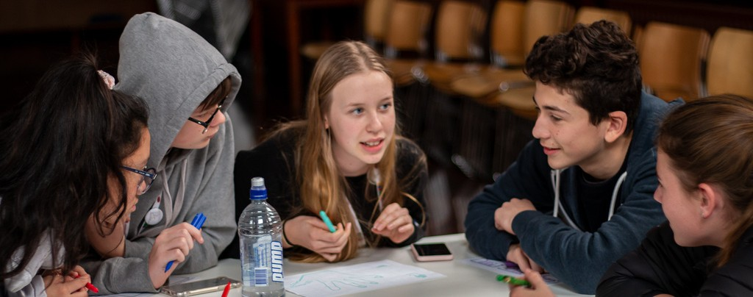
These quotas are part of VicSRC’s constitution.

I want to nominate!

Amazing! If you’re eager to represent Victorian students and advocate for their needs, we encourage you to nominate for Executive – regardless of your background, gender, access requirements, where you live, or where you go to school!

Who can nominate
You can nominate if you are…
- A school-aged student being educated in Victoria.
- In year 7-11 or equivalent.
Students who will finish school at the end of 2022 cannot nominate, because you must be enrolled in secondary education for all of your 2022-23 term.
- Part of the VicSRC Student Community. If you’re not a member of our Student Community yet, no problem! It takes 2 minutes to sign up here.
Commitment
All Executive Committee members are expected to attend several meetings, training camps and key VicSRC events.
They also need to spend on average 2 hours per week on Executive-related work outside of meetings and events.
Key dates for Executive Committee to attend in 2022 are:
2 September - Congress
20-22 September - Induction Camp 17 November - AGM & Student Voice Extravaganza
More detail about event timings and commitments is available in the Position Description included in this information pack.

Support from VicSRC
VicSRC supports students to be a VicSRC Executive Committee member to the best of their ability, and staff work with members to understand their individual access needs.
VicSRC provides the following support for regional and rural students: Reimbursement of costs to travel to Melbourne to attend VicSRC meetings, events and engagements (up to the cost of a VLine ticket).
Supervised overnight accommodation for events that start early in the morning or finish late in the evening.

Before you nominate
Being part of the VicSRC Executive Committee is a really exciting opportunity, but it’s also a big commitment. It’s important that you understand what you’re signing up for! Make sure you go through each step of the nomination process at the start of this pack before you fill out the nomination form.
Here is some more information you might need to know.
Chat with a parent or guardian

Executive Committee members need to attend Saturday meetings once a month, and camps during some school holidays. If you’re from outside of Melbourne, you’ll have to travel into the city for most of these meetings. We want to know that you have the support of your family or support network, and they understand what being an Executive Committee member involves.
Consent
A parent or guardian will also need to give consent for you to nominate for the VicSRC Executive Committee, and for your image to be used on the VicSRC website and other platforms. You can download the consent form here in pdf or word format, or from the VicSRC website. You will need to upload it when you complete your nomination form.

Chat with someone at your school
Executive Committee members are often asked to attend meetings, conferences or other engagements during school hours. Having the support of your school to miss some classes will make things a lot easier for you and help you make the most of your Executive Committee term!
Book into an information session

This year, all candidates must attend a compulsory information session before they nominate. This information session will cover:
The expectations of Executive Committee members. What makes a successful Executive Committee member. Real-life advice from current and former members.
A chance to ask questions about the role.
There are three information sessions to choose from, including online and in- person options. Make sure you book into a session online.
If you are unable to attend any of the information sessions but want to nominate, please contact election@vicsrc.org.au as soon as possible.
Prepare your nomination statement

During the nomination process, you will be asked to submit a short statement to support your nomination. This statement will appear alongside your first name and photo on the VicSRC website and on the online ballot form.
This should be in dot points, be a maximum of 75 words and answer these questions:

  - Why would you be an amazing representative for students?
  - What issue would you want to work on from the priorities from Congress 2021?
  - What do you think is the most important issue in the education system right now?
We will also ask you for a short quote (15 words or less) from you so we can promote you as a great candidate on social media.

Choose your photo to appear on the ballot form
It can be a photo of you or something else that you feel represents you. You will need to upload this photo to the nomination form.
A note about nomination statements and photos

Nomination statements and photos will be approved by the VicSRC returning officers and they may ask nominees to edit or provide a new statement or photo.
VicSRC is a child-safe organisation and reserves the right to remove any information which we think is too identifying. We ask that nominees don’t include their age, year level or specific school in their bio and campaign materials.
This information may be publicly available on the VicSRC website, and may be shared on social media channels:
First name Photo or image Short quote
Candidates can opt out of this information being shared publicly through the talent release form.
This information will be available to members of the VicSRC Student Community who are eligible to vote:
First name School name
Type of school (ie Government/ Catholic/Independent/ Specialist/ Other) School area (ie metro or regional)
Full nomination statement

Election guidelines

The purpose of these guidelines is to encourage a fair and open election for all candidates.

Correspondence and communication
All correspondence and communication regarding the VicSRC Executive Committee election, including questions, should be emailed to election@vicsrc.org.au.

Eligibility for nomination
- Nominees must be current school-aged students in Victoria completing secondary education.
- Nominees must be members of the VicSRC Student Community.
- Nominations can only be submitted through the specified online nomination form.
- The returning officers will confirm that a nomination has been accepted by email.
- Any nominee who wishes to withdraw their nomination can do so by emailing election@vicsrc.org.au before the end of the voting period. If a nominee withdraws after the voting period begins, their information will still appear on the ballot paper.
- Any nominee who is found to have provided misleading information on their nomination form (including, but not limited to, their name, year level, student status, etc) may be investigated by the returning officers and may have their nomination revoked.

Eligibility for voting
- Voters must be members of the VicSRC Student Community before 9am on Monday 25 July 2022.
- Voters must be enrolled in education in Victoria (this includes non-traditional forms of education like home-schooling or distance education).
- The returning officers will conduct random checks to ensure Student Community members are in fact students in Victoria. Any person found to have provided misleading information will be banned from voting and be removed from the VicSRC Student Community.
- Information about voting will be sent to the voter’s registered email address.
- Voters can only vote once, and their vote is final.

Campaigning period

What is campaigning?
Campaigning is when you ask people to vote for you! As a candidate, you might campaign to other students at your school, sporting club, youth group, or local community.
You will want to get people to sign up to VicSRC’s Student Community and then vote for you! The guidelines below will ensure fair campaigning by all candidates.

Campaigning guidelines
The campaigning period for the 2022 Executive Committee election runs from Monday 18 to Sunday 31 July 2022.
Candidates must act honestly and with integrity when campaigning for votes.
They must ensure that their campaign and any physical or online campaign material is accurate and not misleading.
Consistent with free and fair elections, VicSRC will not provide election campaign assistance to candidates.
VicSRC will not support or endorse any candidates but may share information about individual candidates on social media channels to raise awareness about the election.
Each candidate will be asked to provide a photo and candidate statement which will be on the ballot paper. This candidate statement can be edited once only after nominations are received, and any edits must be completed before the voting period opens.

Candidates may use Facebook, Instagram, Twitter, or other online platforms like YouTube to promote their candidacy and are encouraged to tag VicSRC on these platforms! However, candidates should keep in mind that these platforms can be accessed by a much broader audience than VicSRC Student Community members.
In the spirit of honest and fair campaigning, the following will not be tolerated: Bribing voters to register or vote for you; for example, offering gifts or prizes to people who vote for you.
Any negative campaigning, including spreading misinformation, about other candidates or VicSRC.
Statements guaranteeing certain outcomes as a result of your election; for example, “Vote for me and I’ll make sure we get rid of VCE!”
Spending excessive amounts of money on campaigning. Candidates should not spend more than $50 in the creation or distribution of campaign material.
The above rules also apply to schools or other organisations supporting a candidate’s election campaign.
Any candidates found to have breached these guidelines or be behaving in a way that the returning officers find to be contrary to the spirit of the election, will be issued with a formal written warning .
If there is a second breach of these guidelines, the returning officers reserve the right to remove a candidate from the election process.
The returning officers reserve the right to remove candidates from the election process at any time at their own discretion, including for egregious first breaches of the campaigning guidelines.
If you have any questions about campaigning, please email our returning officers at election@vicsrc.org.au.

Counting of votes and declaration of results
VicSRC Executive Committee elections are run using the Borda count method.
The returning officers are responsible for reviewing the election results provided by the online election platform and verifying the results.

Position description VicSRC Student Executive
Advisory Committee 2022-21

Key details
Position title: VicSRC Student Executive Advisory Committee (‘Executive Committee’) member 2022-2023
Main location: VicSRC Office, Our Community House, 55 Victoria Street, North Melbourne
Period: 1 October 2022 – 31 October 2023

Benefits of volunteering as an Executive Committee member
VicSRC was created by students to be a voice for students at the highest levels of decision-making in Victorian education. It is the only student-led, education-based advocacy organisation in Australia! This is a unique opportunity to be part of making change in education. Through this role you will:
Work collaboratively to create a more equitable and effective education system in Victoria.
Create connections and networks that will support you in training and employment.
Develop leadership skills and governance experience and understanding. Develop your organisation, public speaking and presentation skills.
Access training, mentoring, and skill development.
Lead state-wide student-led advocacy and activities with support from staff. Make new friends and meet people from all areas of the community.

Commitment required
All Executive Committee members must be able to attend the following events.

Date* | Event | Location
Friday 2 September  2022 | Congress 2022 | Wurrun Senior Campus, Fitzroy
Tuesday 20 - Thursday 22  September 2022 | Induction camp | Melbourne (accommodation provided)
Thursday 17 November  2022 | Annual General Meeting & Student Voice Extravaganza | Melbourne
January 2023  Date TBC | Planning day | VicSRC office, Melbourne
April 2023  3 days, school holidays | Training camp | Regional Victoria (accommodation provided)
One Saturday a month, 12.30-4.30pm | Monthly Executive Committee meetings.  Generally the last Saturday of the month. | Primarily at VicSRC office in Melbourne, with online options
Date TBC | Congress 2023 | TBC
Ongoing | Attendance and leadership at VicSRC core events as required. Attendance at a minimum of one Board of Trustees meeting throughout the Exec term.
*Dates are subject to change

Executive Committee members also need to spend on average 2 hours per week on VicSRC-related work, which may include:
Reading minutes, agenda, and VicSRC staff reports before every meeting. Attending VicSRC engagements such as meetings with education stakeholders, including the Minister for Education, and VicSRC Board meetings.
Responding to texts, emails and/or group posts within 24 hours on a weekday. Regular meetings with Executive sub-committees, adult Board of Trustees and/or staff members.
If an Executive Committee member can’t meet these requirements, their position may be reviewed by their fellow Executive Committee members.

Role overview
The VicSRC Executive Committee is elected annually by the VicSRC Student Community.
The VicSRC Executive Committee does the following:
Works with the Chief Executive Officer and the Board of Trustees to lead the organisation based on their understanding of Victorian students’ needs.
Determines VicSRC’s response to and position on key education issues on behalf of Victorian students. For example:
VicSRC students have provided evidence on behalf of Victorian students in several education-related government enquiries
VicSRC submits recommendations and advice to government through formal policy submissions
VicSRC’s Policy Platform was written in partnership with the Executive Committee
Represents Victorian students at the state level and advocates for positive change in education
Upholds the principles and values of VicSRC in all areas of their work and lives

Each Executive Committee member will be part of 1-2 sub-committees as determined by the team. More information about sub-committees is included below.

Key responsibilities

Leadership and governance of VicSRC
Maintain the vision, mission and values of VicSRC
Make important decisions about the direction and future of the organisation Consider and approve short term and long-term strategies
Consider and approve VicSRC staff report monthly Consider and reduce risks to the organisation
For more information on what governance is please visit this website.

Advocacy and representation
Consult with students by regularly talking to them about their views and ideas Promote and represent student voice at all levels of decision making including at school, community and at a state level
Attend VicSRC events
Engage and build connections/relationships with key stakeholders Represent the organisation and its key messages at different events, engagements, and other external opportunities.
Share VicSRC communications through personal social media channels

Organisation
Attend all major VicSRC events as outlined above
Take on a leadership role at Congress and other core VicSRC events

Responsibilities of sub-committees
Each Executive Committee member will be part of 1-2 sub-committees as determined by the team. Each sub-committee’s work will be based on the Strategic Plan, VicSRC Policy Platform, and the priorities from Congress. The purpose of these sub-committees is to:
Allow Executive Committee members to focus and upskill in their chosen interest areas.
Maintain clear lines of communication, accountability and workflow throughout the Executive Committee term.

The exact sub-committees will be determined by the Executive Committee and will cover the following areas:

Advocacy
Work with staff and mentors to develop and implement action plans for VicSRC’s advocacy priorities from Congress. This will include:
Interpreting data from Congress.
Identifying measurable advocacy wins within the Congress action plans. Developing and maintaining relationships with other organisations to support VicSRC advocacy.
Creating communications strategies.
Develop advocacy campaigns to support asks identified by students at Congress.
Coordinate involvement of students outside of the Executive Committee (for example, VicSRC Ambassadors and/or Student Community) in advocacy campaigns.

Decision-making and forward planning
Work in partnership with the Board of Trustees.
Attend monthly Board of Trustees meetings on a rotating basis. Represent VicSRC Executive Committee when making decisions on organisational issues such as internal policies, planning and strategy, fundraising etc.
Make sure VicSRC’s work is aligned to the strategic plan.
Consider opportunities and risks to the organisation, including financial, reputational and those associated with staff members and volunteers. Appoint new VicSRC staff as part of a recruitment team. This includes shortlisting and interviewing candidates as part of a panel.

Events and programs
Work with staff to plan for our annual events: Congress
Student Voice Extravaganza Annual General Meeting
Co-facilitate training sessions for students and teachers with VicSRC staff. Advise on any other events and/or programs as required.

Communications/media
Work with staff on external facing communications. Advise on student focused communications, including:
Student Community newsletters VicSRC social media
Coordinate communications content including: Advocacy campaigns
Updates from meetings with external organisations such as the Department of Education and Training
Develop media releases and responses in partnership with the Communications team, including speaking to media on behalf of VicSRC with guidance from staff.

Engagements
Work with the Chief Executive Officer to attend and speak on behalf of the organisation at external engagements (meetings, conferences, workshops etc) Read background papers in preparation for meetings.
Maintain a good understanding of VicSRC advocacy areas and use engagements as opportunities for promoting VicSRC’s advocacy positions. Regular engagements including meetings each term for:
Department of Education and Training reform reference groups – Mental Health in Schools and Senior Secondary.
Marrung Central Governance Committee –Government and community education-based organisations that advise on the ongoing implementation of the Marrung education strategy for Koorie students in Victorian Government schools.
LGBTIQ+ Education Reference Group –Government, Catholic and private education-based organisations advise on the delivery of LGBTIQ+ education programs in all Victorian schools.
Complaints Management Reference Group

Main contacts

Benita Bruce
Student Engagement Manager 0487 085 668
students@vicsrc.org.au
Nina Laitala
Chief Executive Officer 0411 679 050
ceo@vicsrc.org.au

Frequently asked questions
If your question isn’t answered below, please get in touch with us on election@vicsrc.org and we’ll get back to you as soon as we can!

I haven’t done anything with VicSRC before; can I still nominate?
Absolutely! Any Victorian school-aged student in Y7-11 or equivalent, who is also a part of the VicSRC Student Community is eligible to nominate for the VicSRC Executive Committee. You will be given a comprehensive induction to help you understand everything about VicSRC.

Can I nominate if I’m in Year 12 this year?
Unfortunately, if you are due to complete Year 12 in 2022 you are not eligible to nominate for the 2022-23 Executive Committee. All students who sit on the VicSRC Executive must be current students within the Victorian education system. If you want to be involved with VicSRC you should come to Congress 2022 and sign up to the Student Community so you stay informed about any other opportunities!

Do I need to be on my school’s student representative team or student voice body?
No! We’re just looking for students who are passionate and committed. You don’t need to have any previous experience!

If I nominate, do I get to vote as well?
You sure do! We will send you information about voting via email.

I missed the nomination deadline! Is there any way I can still nominate? Oh no! Unfortunately, our deadlines are strict, and we cannot accept late nominations. Hopefully we’ll see you next year!

What are the information sessions for?
The information sessions are compulsory for anyone thinking about nominating for the Executive Committee. They will help you understand more about the role and the commitment required. We also recommend you bring a parent or carer so they can hear this information too. You can book into an information session here.

What if I can't attend any of the information sessions?
There is one in person option and two online options at different times, so we hope one of them suits you! If you really can't make any of the sessions, please email election@vicsrc.org.au.

What if I want to nominate but can’t commit to all the major events?
We really need an Executive team who are available for our major events. If you are super keen to nominate but know that you’re unavailable for something, send us an email at election@vicsrc.org.au and we will get back to you. If you want to be involved with VicSRC in a different way, you can attend Congress 2022 or apply to become an Ambassador next year.

When is the new VicSRC Executive Committee announced?
Candidates will be notified of the outcome of elections by Wednesday 24 August 2022. The VicSRC 2022-23 Executive team will be formally announced at a VicSRC event later in the year.

What are returning officers? Who are they and what do they do?
‘Returning officer’ is a fancy way of saying someone who is in charge of running an election process. The VicSRC Executive Committee has two returning officers each year. Their job is to make sure the election is fair and is conducted in line with VicSRC’s policies and processes. They are also responsible for overseeing all nominations, making sure the ballot paper and voter roll is accurate, and verifying and announcing the results of the election. They must be impartial throughout this process. The VicSRC returning officers this year are Linh and Thanh. You can get in touch with them by emailing election@vicsrc.org.au.

